 Takeda Scientific Symposium
Takeda 2010 Key Opinion Leaders Meeting - Northern
PPI across the Gl & CV Continuum
Program (Draft)
Time | Topic | Chairman / Speaker
0900~0930 | Registration & Breakfast
0930~0940 | Opening Remarks | 吳正雄 理事長
0940~1010 | Lansoprazole and GU & DU  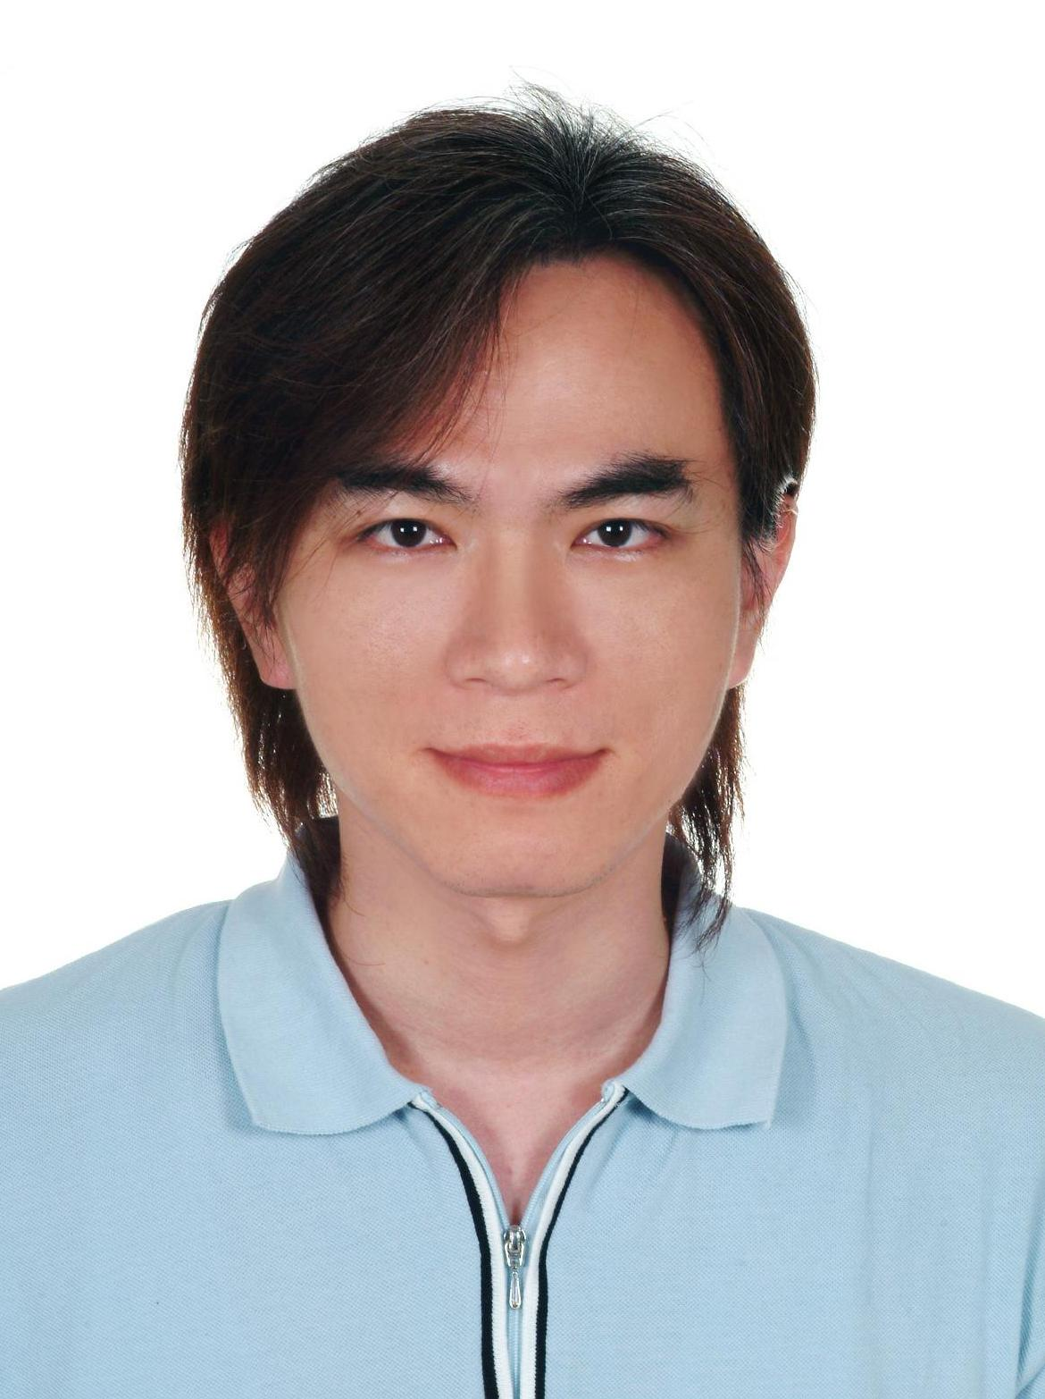 | Ming-Yao Su, MD  Associate Professor,  Department of Gastroenterology and Hepatology,  Chang-Gung Memorial Hospital,  Linkou, TAIWAN  Moderator: 侯明志 教授
1010~1040 | 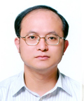  Lansoprazole and GERD & NERD in Taiwan | Ming-Shiang Wu, MD, Ph.D  Professor, Division of Gastroenterology,  Department of Internal Medicine  National Taiwan University Hospital,  Taipei, TAIWAN  Moderator: 張文熊 主任
1040-1120 | Lansoprazole and GERD & NERD in USA   | David A. Peura, MD FACP, MACG, AGAF  Emeritus Professor of Medicine  Division of Gastroenterology and Hepatology,  Department of Internal Medicine  University of Virginia,  Charlottesville, VA, 22908, USA  Moderator: 楊國卿 副院長
1120~1150 | Clinical Discussion | 謝財源 主任  邱正堂 教授
1150~1200 | Closing Remarks | 林肇堂 理事長
Date : March 14, 2010 (Sunday)
Time : 0900 ~ 1200
Venue : 台北晶華酒店
Address : 台北市中山北路二段41號
Tel : 02-2523-8000
Organizers :
學分申請中 : ，，台灣內科醫學會
Sponsor : 台灣武田藥品工業股份有限公司

