 Takeda Scientific Symposium
Takeda 2010 Key Opinion Leaders Meeting - Kaohsiung
PPI across the Gl & CV Continuum
Program (Draft)
Time | Topic | Speaker
1800~1900 | Registration & Dinner
1900~1910 | Opening Remarks | 林肇堂 理事長
1910~1940 | 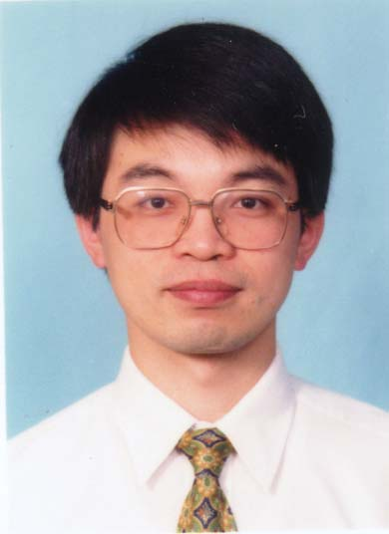  Current management of peptic ulcer bleeding | Ping-I Hsu M.D. Ph. D  Chief, Associate Professor,  Department of Gastroenterology,  Veterans General Hospital,  Kaohsiung, TAIWAN  Moderator: 羅錦河 部長
1940~2010 | 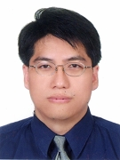  Lansoprazole and GERD & NERD in Taiwan | Keng-Liang Wu, MD,  Assistant Professor,  Department of Gastroenterology and  Hepatology,  Chang-Gung Memorial Hospital,  Kaohsiung, TAIWAN  Moderator: 蔡成枝 主任
2010~2050 | Lansoprazole and GERD & NERD in USA   | David A. Peura, MD FACP, MACG, AGAF  Emeritus Professor of Medicine  Division of Gastroenterology and Hepatology,  Department of Internal Medicine  University of Virginia,  Charlottesville, VA, 22908, USA  Moderator: 吳登強 主任
2050~2120 | Clinical Discussion | 胡琮輝 主任  鄭錦翔 院長  王文明 教授
2120~2130 | Closing Remarks | 黎國洪 副院長
Date : March 12, 2010 (Friday)
Time : 1800-2130
Venue : 高雄金典酒店 (41F星辰廳)
Tel : +886-7-566-8000 Fax : +886-7-566-8080
Address : 高雄市802自強三路1號37~85樓(新光路口)
Organizers :
學分申請中 : ，，台灣內科醫學會
Sponsor : 台灣武田藥品工業股份有限公司

