中區消化系同好會

主題:114年中區消化系同好會
時間:114年5月1日17:30-20:30
地點:台中榮民總醫院研究大樓二樓第三會議室(如附圖)
時間 | 講題 | 講師 | 座長
17:30-18:00 | 腹膜腔之異常感染 | 部立豐原醫院  林明賢醫師 | 台中國軍院  傅俊凱主任
18:00-18:30 | Alcohol-Related Liver Disease (ALD) in Taiwan | 澄清醫院  何士奇主任 | 台中國軍院  傅俊凱主任
18:30-19:00 | 我如何做cholangiogram | 中榮埔里分院  周偉強醫師 | 中榮  彭彥鈞醫師
19:00-19:50 | The Th17 Pathway and IBD Treatment. | 成大醫院內科  莊喬雄教授 | 中榮  彭彥鈞醫師
19:50-20:30 | 議題討論

Alcohol-Related Liver Disease (ALD) in Taiwan
摘要
This speech highlights the escalating public health issue of alcohol-related liver disease (ALD) in Taiwan, emphasizing its increasing prevalence and direct link to alcohol consumption. It details the pathological progression initiated by alcohol metabolism, leading from fatty liver to steatohepatitis, cirrhosis, and ultimately increasing the risk of hepatocellular carcinoma. The toxic metabolite acetaldehyde is identified as a key mediator in this process and is also implicated in alcohol-related brain damage. Furthermore, the text introduces altered gut permeability as a significant factor in ALD pathogenesis, noting emerging research on the gut microbiota's influence on the brain and behavior.
Statistical data from 2002 to 2017 reveals a significant surge in ALD incidence in Taiwan, rising from 8.17 per 100,000 persons to 14.45 per 100,000 persons. This increase strongly correlates with a parallel rise in per capita alcohol consumption, which climbed from 3.1 liters to 4.4 liters during the same period. A strong positive correlation (Pearson’s r = 0.82) confirms this relationship, with statistical analysis indicating that each additional liter of alcohol consumed per capita increases the standard incidence of ALD by 1.91.
The conclusion drawn from this data is stark: the incidence of ALD in Taiwan has significantly increased over the 15-year study period, directly mirroring the growth in alcohol consumption. Given the high rates of complications and mortality associated with ALD, the text strongly advocates for the prioritization of public health policies focused on ALD prevention. This underscores the urgent need for interventions aimed at reducing alcohol consumption within the Taiwanese population to mitigate the growing burden of this severe liver disease.

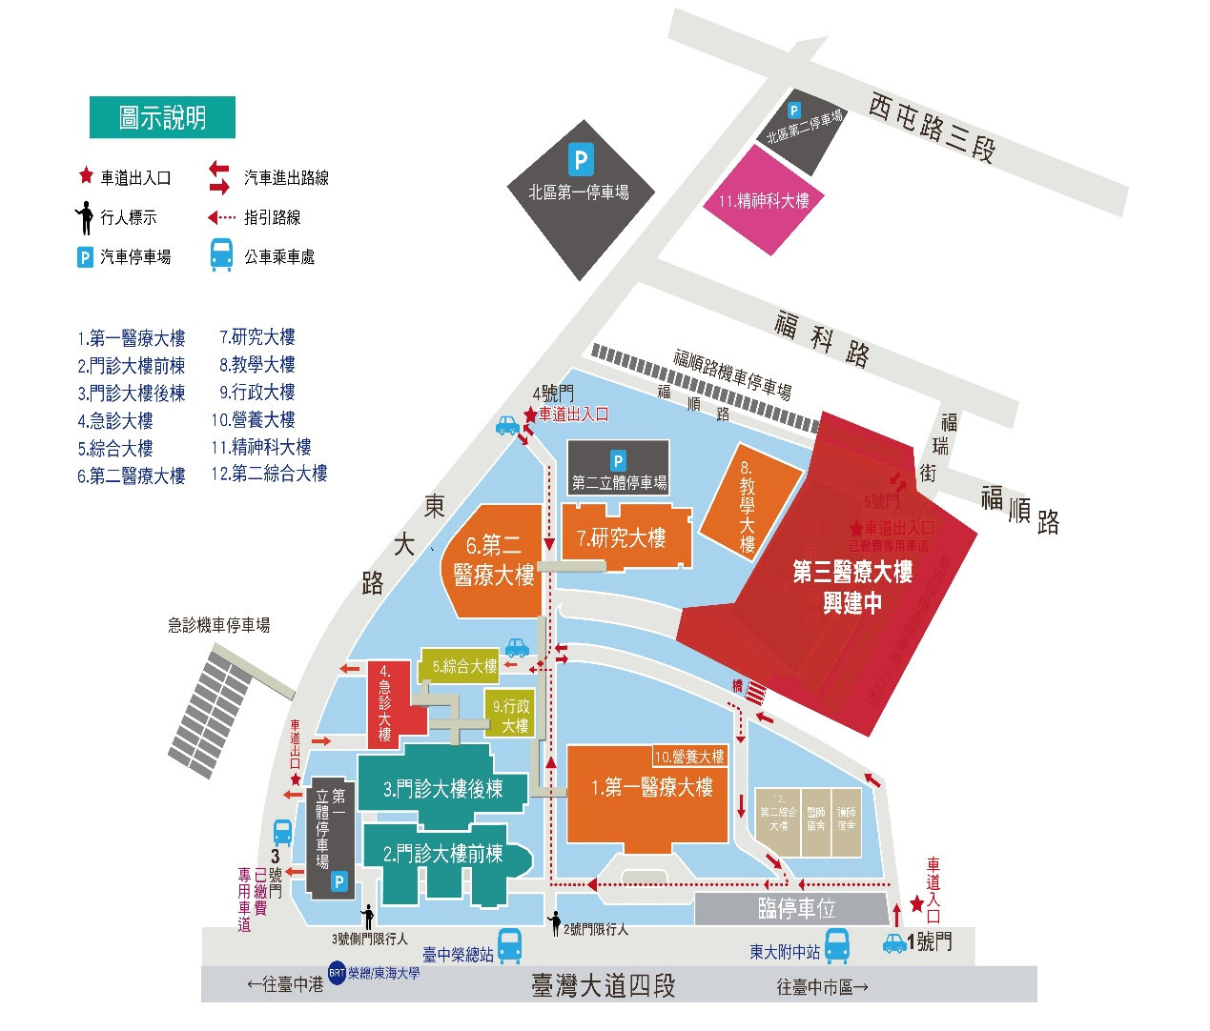
研究大樓二樓第三會議室

