**第一屆微生物組和以微生物組為基礎的治療學研討會**

**1st Symposium on Microbiome and Microbiome-Based Therapeutics (SMMT)**

**日期: 2024年10月05日**

**地點: 林口長庚紀念醫院 研究大樓1樓**

|  |  |  |  |  |
| --- | --- | --- | --- | --- |
| **時間** | **演講者** | **主持人** | **題目** | **演講時間(含討論)** |
| **08:00~08:30** | **報到** | | | |
| **08:30~08:40** | **開場致詞:** 程文俊主委、陳建宗院長、陳冠仰理事長 (台灣腸道醫學會)、吳俊穎理事長 (台灣微菌聯盟)、邱正堂理事長 (台灣消化系內視鏡醫學會) (其他貴賓邀請中) | | | |
| **08:40~09:30** | **Keynote Speaker:**  Gabriel Nuñez  MD/PhD/教授  University of Michigan Medical School, USA | 邱政洵 教授  副院長  林口長庚醫院 | Host-microbiota interactions in health and disease | 50分鐘 |
| **09:30~10:20** | **Keynote Speaker:**  Kiyoshi Takeda  MD/PhD/教授  日本大阪大學 | 謝世良 教授  特聘研究員  免疫醫學研究中心  國家衛生研究院 | Immunoregulation by antigen-presenting cells in gut: Mechanism and clinical implication | 50分鐘 |
| **10:20~10:35** | **Break** | | | |
| **10:35~10:55** | 李柏賢  副教授  胃腸肝膽科  林口長庚醫院 | 羅景全 教授  主任 胃腸肝膽科  臺北榮民總醫院 | Microbiome-based therapeutics for gastrointestinal diseases | 20分鐘 |
| **10:55~11:45** | **Keynote Speaker:**  Laura Martinez-Gili  PhD/教授  Imperial College London, UK | 鄭美玲 教授  生物醫學研究所 長庚大學 | Microbial and metabolomic phenotypes associated with FMT for gastrointestinal diseases | 50分鐘 |
| **11:45~12:15** | 徐瑋萱 副教授  成功大學醫學院 | 黃玉書 教授  主任  精神醫學部  林口長庚醫院 | Microbiome and gut-brain axis | 30分鐘 |
| **12:15~13:20** | **Lunch** | | | |
| **13:20~14:10** | **Keynote Speaker:**  Seth Rakoff-Nahoum  MD/PhD/副教授  Harvard Medical School, USA | 楊皇煜 教授  主任  醫學研究部  林口長庚醫院 | Ecological drivers of microbiota assembly in preterm infants | 50分鐘 |
| **14:10~14:40** | 邱政洵 教授  副院長  林口長庚醫院 | 吳俊忠 講座教授  院長  亞洲大學醫學暨健康學院 | Finding the keystone microbiota controlling gut homeostasis in sepsis | 30分鐘 |
| **14:40~15:10** | 賴信志  CEO  微大生技 | 賴志河 教授  長庚大學生物醫學研究所 | Next generation probiotics and potential clinical use | 30分鐘 |
| **15:10~15:20** | **Break** | | | |
| **15:20~15:40** | 陳倩琪 博士  食品工業發展研究所 (BCRC) | 高正彥 副教授  微生物及免疫學研究所  陽明交通大學 | Prebiotics and probiotics | 20分鐘 |
| **15:40~16:00** | 蔡明釗  副教授  胃腸肝膽科  高雄長庚醫院 | 蔡成枝 教授  副院長  高雄長庚醫院 | FMT for *Clostridioides difficile* infection in liver transplant patients | 20分鐘 |
| **16:00~16:30** | 吳偉愷  副教授  胃腸肝膽科  臺大醫院 | 張明鈴 教授  主任  胃腸肝膽科  林口長庚醫院 | Quantification of fecal bbu genes predicts L-carnitine-mediated TMAO production | 30分鐘 |
| **16:30~16:40** | **Closing Remarks** | | | |

**主辦:** 林口長庚紀念醫院 (醫學研究發展部、胃腸肝膽科、兒童內科部、分子感染症醫學研究中心、微菌治療中心)

**協辦:** 國家科學及技術委員會、台灣腸道醫學會、台灣微菌聯盟、台灣兒童感染症醫學會、台灣微生物學會、台灣消化系內視鏡醫學會、長庚大學分子醫學中心

BIOGRAPHICAL SKETCH

Provide the following information for the Senior/key personnel and other significant contributors. 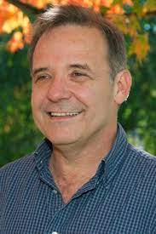  
Follow this format for each person. **DO NOT EXCEED FIVE PAGES.**

Email: [gabriel.nunez@umich.edu](mailto:gabriel.nunez@umich.edu)

NAME: Nuñez, Gabriel

eRA COMMONS USER NAME (credential, e.g., agency login): nunezbcl

POSITION TITLE: Paul de Kruif Professor of Pathology

EDUCATION/TRAINING (Begin with baccalaureate or other initial professional education, such as nursing, include postdoctoral training and residency training if applicable. Add/delete rows as necessary.)

| INSTITUTION AND LOCATION | DEGREE  (if applicable) | Completion Date  MM/YYYY | FIELD OF STUDY |
| --- | --- | --- | --- |
| University of Seville Medical School, Spain | MD | 06/1977 | Medicine |
| UT Southwestern Medical Center, Dallas, TX | Postdoctoral | 06/1985 | Immunology |
| Washington University, St. Louis, MO | Resident | 06/1990 | Pathology |
| Howard Hughes Medical Institute, St. Louis, MO | Postdoctoral | 12/1990 | Molecular Biology |

**Kiyoshi TAKEDA, M.D. , Ph.D.**

Status Professor

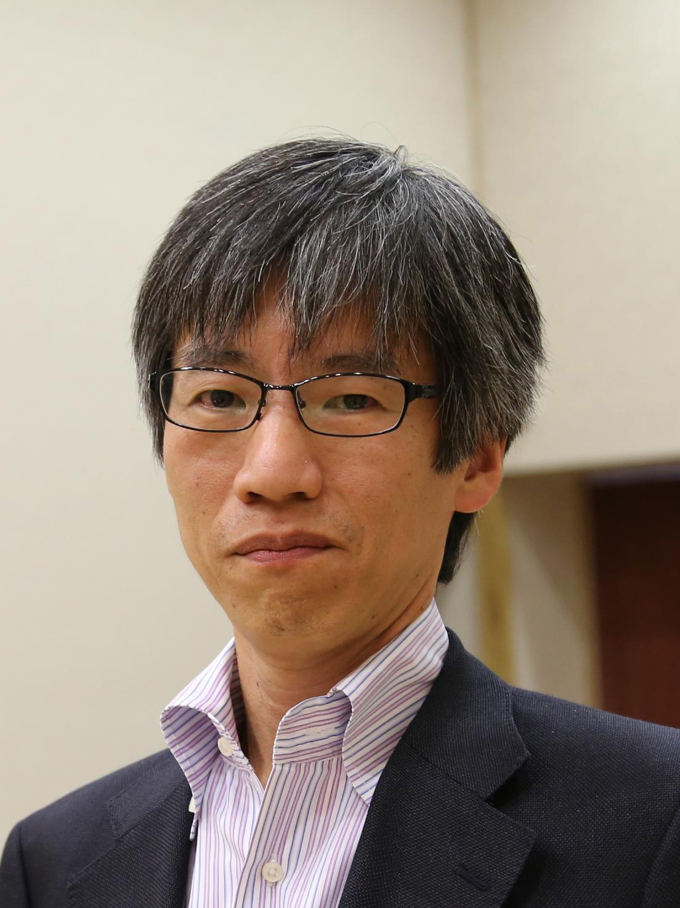

Photograph of the presenting author

(40mm x 30mm)

Affiliation Immunology Frontier Research Center, Osaka University

Address 2-2 Yamada-oka, Suita, Osaka 565-0871, Japan

Nationality Japan

Phone +81-6-6879-3982; Fax: +81-6-6879-3989

E-mail [ktakeda@ongene.med.osaka-u.ac.jp](mailto:ktakeda@ongene.med.osaka-u.ac.jp)

**Research Fields of Interest**

Mucosal Immunology, Inflammation, Microbiota, Epithelia

**Education and Appointment**

1992 M. D. Osaka University, Medical School

1998 Ph. D. Osaka University, Graduate School of Medicine

1998-1999 Research Associate, Hyogo College of Medicine

1999-2003 Research Associate, Research Institute for Microbial Diseases,

Osaka University

2003-2007 Professor, Medical Institute of Bioregulation, Kyushu University

2007-Present Professor, Immunology Frontier Research Center,

Graduate School of Medicine, Osaka University

2019-Present Director, Immunology Frontier Research Center, Osaka University

**Selected Publications**

1. Yokoi T, Murakami M, Kihara T, Seno S, Arase M, Wing JB, Søndergaard JN, Kuwahara R, Minagawa T, Oguro-Igashira E, Motooka D, Okuzaki D, Mori R, Ikeda A, Sekido Y, Amano T, Iijima H, Ozono K, Mizushima T, Hirota S, Ikeuchi H, Takeda K: **Identification of a unique subset of tissue resident memory CD4+ T cells in Crohn's disease. *Proc. Natl. Acad. Sci. USA*** 120, e2204269120 (2023).
2. Morita N, UmemotoE, Fujita S, HayashiA, Kikuta J, KimuraI, HanedaT, ImaiT, InoueA, MimuroH, Maeda Y, Kayama H, Okumura R, AokiJ, OkadaN, KidaT, IshiiM, Nabeshima R, Takeda K: GPR31-dependent dendrite protrusion of intestinal CX3CR1+ cells by bacterial metabolites.***Nature***566,110-114 (2019).
3. Okumura R, Kurakawa T, Nakano T, Kayama H, Kinoshita M, Motoka D, Gotoh K, Kimura T, Kamiyama N, Kusu T, Ueda Y, Wu H, Iijima H, Barman S, Osawwa H, Matsuno H, Nishimura J, Ohba Y, Nakamura S, Iida T, Yamamoto M, Umemoto E, Sano K, Takeda K: Lypd8 promotes the segregation of flagellated microbiota and colonic epithelia. ***Nature*** 532, 117-121 (2016)
4. Tsai SH, Kinoshita M, Kusu T, Kayama H, Okumura R, Ikeda K, Shimada Y, Takeda A, Yoshikawa S, Kurashima Y, Sato S, Umemoto E, Kiyono H, Karasuyama H, Takeda K: Ectoenzyme E-NPP3 (CD203c) negatively regulates ATP-dependent chronic allergic responses by basophils and mast cells. ***Immunity*** 42, 279-293 (2015).
5. Atarashi K, Nishimura J, Shima T, Umesaki Y, Yamamoto M, Onoue M, Yagita H, Ishii N, Evans R, Honda K, Takeda K: ATP drives lamina propria TH17 cell differentiation. ***Nature*** 455, 808-812 (2008).

**Laura Martinez-Gili, PhD, AFHEA**



[laura.martinez@imperial.ac.uk](mailto:laura.martinez@imperial.ac.uk)

+44 745 6911 634

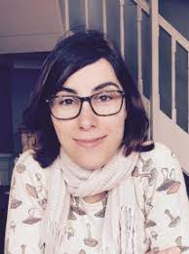

Liver unit/Division of Digestive Diseases, Department of Metabolism, Digestion and Reproduction, Faculty of Medicine. St Mary’s Hospital Campus, Imperial College London, 10th Floor, QEQM Wing, South Wharf Road, Paddington W2 1NY, UK

**Qualifications**

2009-2014 Doctor of Philosophy (PhD), *Universitat de Barcelona* (UB), Barcelona, Spain. “Role of ceramide produced by *de novo* synthesis in the lipotoxicity of non- alcoholic steatohepatitis”.

2009-2010 Master’s degree in Biomedical Research, *Universitat Pompeu Fabra* (UPF), Barcelona, Spain.

2004-2009 Bachelor’s degree in Biotechnology, *Universitat Autonoma de Barcelona*

(UAB), Barcelona, Spain.

**Current and previous appointments**

2021-present Research Fellow, Imperial College London, London, UK.

Lead in multi-omics and bioinformatics of the NIHR BRC Digestive Health theme. Design, planning, implementation and supervision of omics and statistics analytical frameworks for clinical studies aimed at understanding metabolic and infectious disease phenotypes and mechanisms of treatment effectiveness.

2019-2021 Postdoctoral Research Associate, Imperial College London, London, UK. Development and implementation of tailored bioinformatic pipelines and software for the analysis of clinical multi-omics datasets to improve diagnosis, prognosis and treatments of metabolic and gastrointestinal diseases (NIHR BRC Gut Health theme).

2015-2019 Postdoctoral Research Associate, Imperial College London, London, UK. Study of gut microbiota and its derived metabolites in neurodevelopmental disorders, neuroinflammation and cognition (ERA-NET NeuroINF project).

**Invited talks**

|  |  |
| --- | --- |
| 2023 | *The gut microbiome role in the inadequate response to UDCA in primary biliary* |
| 2023 | *cholangitis*. Liver Unit Research Highlights, London (UK).  *Faecal microbiota transplantation, are bacteria the cornerstone?* European Congress |
| 2021 | of Clinical Microbiology and Infectious Diseases (ECCMID), Copenhagen (Denmark).  *Challenges of analysing microbes*. MDR Bioinformatics seminar series, London (UK). |
| 2021 | *Exploring bacterial and metabolic phenotypes in twins with inflammatory bowel* |
| 2018 | *disease*. Microbiome Network annual meeting, London (UK).  *Disease modulation by host and gut microbiota metabolism*. MRC London Institute of |
|  | Medical Sciences, London (UK). |
| 2017 | *The gut microbiome in a mouse model of Down’s Syndrome*. Nutrition and |
| 2016 | microbiome seminar series, London (UK).  *µNeuroINF: The Gut Microbiome in Neuroinflammation and Neuro-developmental* |
|  | *Disorders*. Nutrition and microbiome seminar series, London (UK). |

**Workshops**

2023 Microbiome in chronic liver disease. EASL Basic Science School, London (UK).

**Seth Rakoff-Nahoum, MD, PhD**

**Format for the Curriculum Vitae**

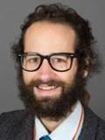

|  |  |
| --- | --- |
| **Date Prepared:** | **09/13/23** |
| **Name:** | **Seth Rakoff-Nahoum** |
| **Office Address:** | **Boston Children’s Hospital**  **300 Longwood Avenue**  **Boston, MA 02115** |
| **Home Address:** | 52 Fulkerson St.  Cambridge, MA 02141 |
| **Work Phone:** | **617-919-2999** |
| **Work Email:** | **[seth.rakoff-nahoum@childrens.harvard.edu](mailto:seth.rakoff-nahoum@childrens.harvard.edu)** |
| **Work FAX:** | 617-730-0254 |
| **Place of Birth:** | Brooklyn, NY |

[Education](http://cv.hms.harvard.edu/index.php?page=education" \o "click for detailed instructions)

|  |  |  |  |
| --- | --- | --- | --- |
| Year | Degree  (Honors) | Fields of Study  (Thesis advisor for doctoral research degrees) | Institution |

|  |  |  |  |
| --- | --- | --- | --- |
| 05/1998 | BA | Biology (with honors)  Religious Studies | Brown University |
| 05/2006 | PhD | Department of Immunobiology Laboratory of Ruslan Medzhitov | Yale University |
| 05/2009 | MD | Medicine (Medical Scientist Training Program) | Yale University School of Medicine |
|  |  |  |  |

Postdoctoral Training

|  |  |  |  |
| --- | --- | --- | --- |
| Year(s) | Title | Specialty/Discipline  (Lab PI for postdoctoral research) | Institution |

|  |  |  |  |
| --- | --- | --- | --- |
| 07/09-06/10 | Intern | Pediatrics | Boston Combined Residency in Pediatrics (Boston Children’s Hospital and Boston Medical Center) |
| 07/10-06/12 | Resident | Pediatrics | Boston Combined Residency in Pediatrics (Boston Children’s Hospital and Boston Medical Center) |
| 07/12-06/15  07/12-06/16 | Clinical Fellow  Postdoctoral Fellow | Pediatric Infectious Diseases  Infectious Diseases  (Laboratory of Laurie Comstock) | Boston Children’s Hospital  Brigham and Women’s Hospital/Harvard Medical School |

Faculty Academic Appointments

|  |  |  |  |
| --- | --- | --- | --- |
| Year(s) | Title | Specialty/Discipline  (Lab PI for postdoctoral research) | Institution |

|  |  |  |  |
| --- | --- | --- | --- |
| 07/15-06/16 | Instructor | Pediatrics | Harvard Medical School |
| 07/16-02/22  11/17-  4/18-  1/22-  02/23-present | Assistant Professor  Associate Member  Affiliated Faculty  Affiliated Faculty  Associate Professor | Pediatrics  Department of Microbiology  Center on the Developing Child  Pediatrics | Harvard Medical School  Broad Institute  Harvard Medical School  Harvard University  Harvard Medical School |
|  |
|  |
|  |  |  |  |

Appointments at Hospitals/Affiliated Institutions

|  |  |  |  |
| --- | --- | --- | --- |
| 07/15-06/16 | Assistant in Medicine | Medicine | Boston Children’s Hospital |
| 07/16—2/23  07/16-  07/16-  07/16-10/18  04/17-  02/23-present | Associate in Medicine  Consultant Staff  Affiliate Staff  Consult Staff  Boston Children’s Hospital Microbiome Research  Endowed Investigator  Senior Associate in Medicine | Medicine (Infectious Diseases)  Medicine (Infectious Diseases) | Boston Children’s Hospital  BIDMC  BWH  DFCI  Boston Children’s Hospital  Boston Children’s Hospital |

CURRICULUM VITAE   
Name: Cheng-Hsun Chiu   
Sex: Male Birth Date: July 14, 1963 Birth Place: Miaoli, Taiwan Citizenship: R.O.C. Office Address: Department of Pediatrics, Chang Gung Children's Hospital, No. 5 Fu-Shin St., Kweishan 333, Taoyuan, Taiwan, R.O.C. FAX: (03)3288957 TEL: (03)3281200-8202 Education: 1. M.D. June, 1989, Chung Shan Medical and Dental College 2. Ph.D. September, 1997, Graduate Institute of Clinical Medicine, Chang Gung University College of Medicine (Supervisor: Prof. Jonathan T. Ou) 3. Postdoctoral Fellow, October 1997-March 1999, Division of Infectious and Immunological Diseases, Department of Pediatrics, University of British Columbia, Vancouver, British Columbia, Canada (Supervisor: Prof. David P. Speert) Employment Record: 1. Resident, June 28, 1989-June 30, 1992, Department of Pediatrics, Chang Gung Memorial Hospital. 2. Chief Resident, July 1, 1992-June 30, 1993, Department of Pediatrics, Chang Gung Memorial Hospital. 3. Attending Physician, since July 1, 1993, Department of Pediatrics, Chang Gung Children's Hospital. 4. Assistant Professor, July 1, 1995-June 30, 2003, Department of Pediatrics, Chang Gung Children's Hospital and Chang Gung University. 5. Associate Professor, July 1, 2003-June 30, 2005, Department of Pediatrics, Chang Gung Children's Hospital and Chang Gung University. 6. Professor, since July 1, 2005, Department of Pediatrics, Chang Gung Children's Hospital and Chang Gung University. Honors: 1. Best Intern Award, 1989, Chang Gung Memorial Hospital. 2. Louis Pasteur Award, 1st place of free paper presentation in microbiology, 1st World Congress of Pediatric Infectious Diseases, World Society of Pediatric Infectious Diseases, 1996. 3. Merck Foundation Research Award, 1997, Merck Sharp & Dohme (I.A.) Corp., Taiwan Branch and Chinese Taipei Pediatric Association. 4. First prize in free paper, 2001 Annual Meeting of Chinese-American Microbiology Society, May 21, 2001, Orlando, Florida, U.S.A.: Su LH, Chiu CH, Wu TL, Ou JT, Riley TV, Chang BJ. Penetration of clinical isolates of Serratia marcescens through MDCK epithelial monolayer.

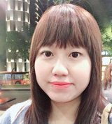

**徐 瑋萱**

副教授

* [食品安全衛生暨風險管理研究所](https://researchoutput.ncku.edu.tw/zh/organisations/department-of-food-safety-hygiene-and-risk-management)
* 電話886 6 2353535 ext 5354
* 電子郵件[whhsu@mail.ncku.edu.tw](https://researchoutput.ncku.edu.tw/zh/persons/wei-hsuan-hsu)

 個人檔案

學歷

* 國立臺灣大學生化科技學系 博士

經歷

* 2018 ~ 迄今 國立成功大學食品安全衛生暨風險管理研究所 助理教授
* 2015 ~ 2018 工業技術研究院生醫與醫材研究所 研究員
* 2014 ~ 2015 美國普渡大學醫藥科學系 博士後研究員
* 2013 ~ 2014 國立臺灣大學生化科技學系 博士後研究員

研究專長

* 食品微生物
* 食品發酵與生物技術
* 新型食品加工
* 食品品質管制
* 機能性食品
* 微生物與腸道功能

Curriculum Vitae   
Name：Le, Puo-hsien (李柏賢) Education： 2001/9-2009/6 Chang Gung University College of Medicine, Taoyuan 333, Taiwan Post-Graduate Education： 2013/06/24 Tumor speciallist training course 2014/07 National Cancer Center, Tokyo, Japan 2018/12/21-22 Cellular therapy traning course 2019/01/05 Fecal microbiota transplantation training course 2019/11 University of Chicago IBD Center Academic Appointment（lnclude Teaching Experience）： 1. Member of the new Editorial Board for the Artificial Intelligence in Gastroenterology, 2021/01/01 – 2024/12/31 2. Official peer reviewer for the World Journal of Clinical Cases. 2021/09/01 – 3. Deputy Secretary-General, Taiwan Association for the Study of Small Intestinal Diseases, 2019/03/31-2022/03/31 Employment Record： 2009/08-2014/7 Resident, Internal Medicine, Chang Gung Memorial Hospital, Linkou branch, Taoyuan 2012/08-2014/7 Fellowship, Department of Gastroenterology and Hepatology, Chang Gung Memorial Hospital, Linkou branch, Taoyuan 2014/08/01-2018/07/01 Attending physician, Department of Gastroenterology and Hepatology, Chang Gung Memorial Hospital, Linkou branch, Taoyuan 2018/07/01-2022/07/01 Assistant professor, attending physician, Department of Gastroenterology and Hepatology, Chang Gung Memorial Hospital, Linkou branch, Taoyuan 2022/07/01- Associate professor, attending physician, Department of Gastroenterology and Hepatology, Chang Gung Memorial Hospital, Linkou branch, TaoyuanCurriculum Vitae Name：Le, Puo-hsien (李柏賢) Education： 2001/9-2009/6 Chang Gung University College of Medicine, Taoyuan 333, Taiwan Post-Graduate Education： 2013/06/24 Tumor speciallist training course 2014/07 National Cancer Center, Tokyo, Japan 2018/12/21-22 Cellular therapy traning course 2019/01/05 Fecal microbiota transplantation training course 2019/11 University of Chicago IBD Center Academic Appointment（lnclude Teaching Experience）： 1. Member of the new Editorial Board for the Artificial Intelligence in Gastroenterology, 2021/01/01 – 2024/12/31 2. Official peer reviewer for the World Journal of Clinical Cases. 2021/09/01 – 3. Deputy Secretary-General, Taiwan Association for the Study of Small Intestinal Diseases, 2019/03/31-2022/03/31 Employment Record： 2009/08-2014/7 Resident, Internal Medicine, Chang Gung Memorial Hospital, Linkou branch, Taoyuan 2012/08-2014/7 Fellowship, Department of Gastroenterology and Hepatology, Chang Gung Memorial Hospital, Linkou branch, Taoyuan 2014/08/01-2018/07/01 Attending physician, Department of Gastroenterology and Hepatology, Chang Gung Memorial Hospital, Linkou branch, Taoyuan 2018/07/01-2022/07/01 Assistant professor, attending physician, Department of Gastroenterology and Hepatology, Chang Gung Memorial Hospital, Linkou branch, Taoyuan 2022/07/01- Associate professor, attending physician, Department of Gastroenterology and Hepatology, Chang Gung Memorial Hospital, Linkou branch, Taoyuan

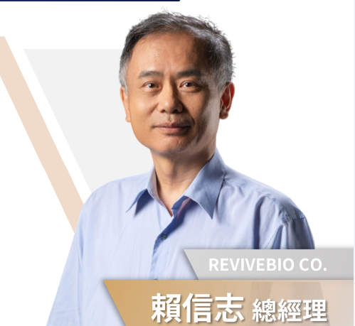

* 賴信志總經理 微大生技REVIVEBIO CO., LTD. 總經理

[](https://web.nstc.gov.tw/cen/oaa/award_109/48301694604.html#top)

**賴信志 主任**

•微大生技REVIVEBIO CO., LTD. 總經理

長庚大學 微生物相研究中心主任

長庚大學 特聘教授

台灣微生物學會常務理事  
台灣微菌聯盟理事

**學歷**

* 英國劍橋大學病理系所博士 ( 1994 )
* 國立陽明醫學院微生物及免疫學系所碩士 ( 1988 )
* 國立臺灣大學醫技系學士 ( 1986 )

**經歷**

* 長庚大學微生物相研究中心 ( 2018/3 ～ 迄今 )
* 長庚大學醫學生物技術暨檢驗學教授及國立臺灣大學兼任教授 ( 2007/8 ～ 迄今 )
* 長庚大學醫學生物技術暨檢驗學系主任／ 所長 ( 2007/8～2018/7 )

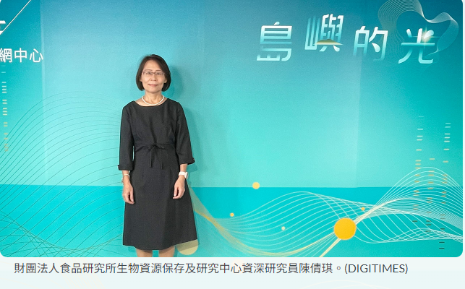

陳倩琪 chj@firdi.org.tw 03-5223191轉593 03-5224171

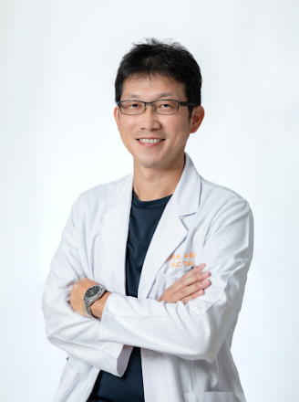  
蔡明釗

長庚醫療財團法人高雄長庚紀念醫院 主治醫師

醫師專長

* 慢性B,C肝炎治療
* 肝癌診斷及侵入性射頻燒灼治療
* 消化道疾病及診斷性內視鏡

醫師專科

* 胃腸肝膽科

看診單位

|  |  |
| --- | --- |
| 駐診單位 | 長庚醫療財團法人高雄長庚紀念醫院 |
| 執業縣市 | 高雄市 |

醫師經歷

|  |  |
| --- | --- |
| 現職 | 高雄長庚紀念醫院 胃腸肝膽科系 肝臟科負責人(2023.07)  高雄長庚紀念醫院 胃腸肝膽科系 副教授主治醫師(2020.07) |
| 經歷 | 高雄長庚紀念醫院  胃腸肝膽科系病房主任  高雄長庚醫院內科部住院醫師  高雄長庚醫院胃腸肝膽科系研究員  高雄縣鳳山醫院胃腸肝膽科主治醫師  長庚大學  醫學系兼任助理教授 |

醫師學歷

* 中國醫藥大學中醫學系畢
* 長庚大學臨床醫學研究所博士班畢業(2022.01)
* 美國西奈山醫院Mount Sinai Hospital 進修
* ---肝臟移植後纖維化分子生物醫學暨臨床移植肝臟醫學研究(2014.7~2016.6)

偉愷醫師

|  |  |
| --- | --- |
| ▍聯繫資訊   * 辦公室：第六共研 * 電話：GSM 52728 * Email：weikaiwu0115@gmail.com * 實驗室網站：建置中     ▍學歷   * 臺灣大學食品科技研究所博士 * 慈濟大學醫學系學士 | 吳偉愷醫師 |
| ▍經歷   * 臺大醫院醫學研究部主治醫師 * 臺大醫院北護分院肝膽腸胃科主治醫師 * 臺大醫院肝膽腸胃科研修醫師 * 臺大醫院內科總醫師     ▍主要專長   * 人體微生物叢 * 腸道菌研究方法學     ▍研究方向   * Gut microbiota and cardiometabolic disease * Gut-liver axis * Next generation probiotics     ▍近五年論文發表   * **Wei-Kai Wu**, Ekaterina A Ivanova, Alexander N Orekhov. Gut microbiome: A possible common therapeutic target for treatment of atherosclerosis and cancer. *Seminars in Cancer Biology*. 2021 May;70:85-97. DOI: [10.1016/j.semcancer.2020.06.017](https://doi.org/10.1016/j.semcancer.2020.06.017" \t "_blank" \o "[另開視窗] 連結論文原文). * **Wei-Kai Wu**, Yi-Hsun Chen, Po-Chu Lee, Po-Jen Yang, Chin-Chen Chang, Kao-Lang Liu, Cheng-Chih Hsu, Chi-Chang Huang, Hsiao-Li Chuang, Lee-Yan Sheen, Chun-Jen Liu and Ming-Shiang Wu. Mining Gut Microbiota from Bariatric Surgery for MAFLD. *Frontiers in Endocrinology*. 2021 Apr 9;12:612946. DOI: [10.3389/fendo.2021.612946](https://doi.org/10.3389/fendo.2021.612946" \t "_blank" \o "[另開視窗] 連結論文原文). * Chieh-Chang Chen, **Wei-Kai Wu**, Chih-Min Chang, Suraphan Panyod, Tzu-Pin Lu, Jyh-Ming Liou, Yu-Jen Fang, Eric Y Chuang, Ming-Shiang Wu (2020, Feb). Comparison of DNA stabilizers and storage conditions on preserving fecal microbiota profiles. *Journal of the Formosan Medical Association*. 2020 Dec;119(12):1791-1798. DOI: [10.1016/j.jfma.2020.01.013](https://doi.org/10.1016/j.jfma.2020.01.013). * Chih-Fan Yeh, Ying-Hsien Chen, Sheng-Fu Liu, Hsien-Li Kao, Ming-Shiang Wu, Kai-Chien Yang, **Wei-Kai Wu\***. Mutual Interplay of Host Immune System and Gut Microbiota in the Immunopathology of Atherosclerosis. *International Journal of Molecular Sciences*. 2020 Nov 19;21(22):8729. DOI: [10.3390/ijms21228729](https://doi.org/10.3390/ijms21228729). \*Corresponding author * **Wei-Kai Wu**, Suraphan Panyod, Po-Yu Liu, Chieh-Chang Chen, Hsien-Li Kao, Hsiao-Li Chuang, Ying-Hsien Chen, Hsin-Bai Zou, Han-Chun Kuo, Ching-Hua Kuo, Ben-Yang Liao, Tina H T Chiu, Ching-Hu Chung, Angela Yu-Chen Lin, Yi- Chia Lee, Sen-Lin Tang, Jin-Town Wang, Yu-Wei Wu, Cheng-Chih Hsu, Lee- Yan Sheen, Alexander N Orekhov, Ming-Shiang Wu. Characterization of TMAO productivity from carnitine challenge facilitates personalized nutrition and microbiome signatures discovery. *Microbiome*. 2020 Nov 19;8(1):162. DOI: [10.1186/s40168-020-00912-y](https://doi.org/10.1186/s40168-020-00912-y" \t "_blank" \o "[另開視窗] 連結論文原文). * **Wei-Kai Wu**, Jyh-Ming Liou, Cheng-Chih Hsu, Yung-Hsiang Lin, Ming-Shiang Wu. Pandemic preparedness in Taiwan. *Nature Biotechnology*. 2020 Aug;38(8):932-933. DOI: [10.1038/s41587-020-0630-0](https://doi.org/10.1038/s41587-020-0630-0" \t "_blank" \o "[另開視窗] 連結論文原文). * **Wei-Kai Wu**, Cheng-Chih Hsu, Lee-Yan Sheen, Ming-Shiang Wu. Measurement of Gut Microbial Metabolites in Cardiometabolic Health and Translational Research. *Rapid Communications in Mass Spectrometry*. 2020 Apr;34 Suppl 1:e8537. DOI: [10.1002/rcm.8537](https://doi.org/10.1002/rcm.8537). * **Wei-Kai Wu**, Lee-Yan Sheen, Ming-Shiang Wu. Response to the letter: Identification of trimethylamine N-oxide (TMAO)-producer phenotype is interesting, but is it helpful?. *Gut.* 2020 Mar;69(3):610-611. DOI: [10.1136/gutjnl-2018-318187](https://doi.org/10.1136/gutjnl-2018-318187" \t "_blank" \o "[另開視窗] 連結論文原文). * Suraphan Panyod, **Wei-Kai Wu**, Kuan-Hung Lu, Chun-Ting Liu, Yung-Lin Chu, Chi-Tang Ho, Wen Luan Wendy Hsiao, Ming-Shiang Wu, Yi-Syuan Lai, Wei- Cheng Chen, Yu-En Lin, Shi-Hang Lin, Lee-Yan Sheen. Allicin Modifies the Composition and Function of the Gut Microbiota in Alcoholic Hepatic Steatosis Mice. *Journal of Agricultural and Food Chemistry*, 2020 Mar 11;68(10):3088-3098. DOI: [10.1021/acs.jafc.9b07555](https://doi.org/10.1021/acs.jafc.9b07555). * **Wei-Kai Wu**, Chieh-Chang Chen, Po-Yu Liu, Suraphan Panyod, Ben-Yang Liao, Pei-Chen Chen, Hsien-Li Kao, Han-Chun Kuo, Ching-Hua Kuo, Tina H T Chiu, Rou-An Chen, Hsiao-Li Chuang, Yen-Te Huang, Hsin-Bai Zou, Cheng-Chih Hsu, Ting-Yan Chang, Chin-Lon Lin, Chi-Tang Ho, Hon-Tsen Yu, Lee-Yan Sheen, Ming-Shiang Wu. Identification of TMAO-producer phenotype and host-diet-gut dysbiosis by carnitine challenge test in human and germ-free mice. *Gut.* 2019 Aug;68(8):1439-1449. DOI: [10.1136/gutjnl-2018-317155](https://doi.org/10.1136/gutjnl-2018-317155" \t "_blank" \o "[另開視窗] 連結論文原文). * Ya-Lin Hsu, Chieh-Chang Chen, Ya-Ting Lin, **Wei-Kai Wu**, Lin-Chau Chang, Chang-Hao Lai, Ming-Shiang Wu, Ching-Hua Kuo (2019, Mar). Evaluation and optimization of sample handling methods for quantification of short-chain fatty acids in human fecal samples by GC-MS.. *Journal of Proteome Research.*2019 May 3;18(5):1948-1957. DOI: [10.1021/acs.jproteome.8b00536](https://doi.org/10.1021/acs.jproteome.8b00536). * **Wei-Kai Wu**, Chieh-Chang Chenc, Suraphan Panyod, Rou-An Chen, Ming- Shiang Wu, Lee-Yan Sheen, Shan-Chwen Chang. Optimization of Fecal Sample Processing for Microbiome Study — The Journey from Bathroom to Bench. *Journal of the Formosan Medical Association.*2019 Feb;118(2):545-555. DOI: [10.1016/j.jfma.2018.02.005](https://doi.org/10.1016/j.jfma.2018.02.005). | |

偉愷醫師

|  |  |
| --- | --- |
| ▍聯繫資訊   * 辦公室：第六共研 * 電話：GSM 52728 * Email：weikaiwu0115@gmail.com * 實驗室網站：建置中     ▍學歷   * 臺灣大學食品科技研究所博士 * 慈濟大學醫學系學士 | 吳偉愷醫師 |
| ▍經歷   * 臺大醫院醫學研究部主治醫師 * 臺大醫院北護分院肝膽腸胃科主治醫師 * 臺大醫院肝膽腸胃科研修醫師 * 臺大醫院內科總醫師     ▍主要專長   * 人體微生物叢 * 腸道菌研究方法學     ▍研究方向   * Gut microbiota and cardiometabolic disease * Gut-liver axis * Next generation probiotics     ▍近五年論文發表   * **Wei-Kai Wu**, Ekaterina A Ivanova, Alexander N Orekhov. Gut microbiome: A possible common therapeutic target for treatment of atherosclerosis and cancer. *Seminars in Cancer Biology*. 2021 May;70:85-97. DOI: [10.1016/j.semcancer.2020.06.017](https://doi.org/10.1016/j.semcancer.2020.06.017). * **Wei-Kai Wu**, Yi-Hsun Chen, Po-Chu Lee, Po-Jen Yang, Chin-Chen Chang, Kao-Lang Liu, Cheng-Chih Hsu, Chi-Chang Huang, Hsiao-Li Chuang, Lee-Yan Sheen, Chun-Jen Liu and Ming-Shiang Wu. Mining Gut Microbiota from Bariatric Surgery for MAFLD. *Frontiers in Endocrinology*. 2021 Apr 9;12:612946. DOI: [10.3389/fendo.2021.612946](https://doi.org/10.3389/fendo.2021.612946). * Chieh-Chang Chen, **Wei-Kai Wu**, Chih-Min Chang, Suraphan Panyod, Tzu-Pin Lu, Jyh-Ming Liou, Yu-Jen Fang, Eric Y Chuang, Ming-Shiang Wu (2020, Feb). Comparison of DNA stabilizers and storage conditions on preserving fecal microbiota profiles. *Journal of the Formosan Medical Association*. 2020 Dec;119(12):1791-1798. DOI: [10.1016/j.jfma.2020.01.013](https://doi.org/10.1016/j.jfma.2020.01.013). * Chih-Fan Yeh, Ying-Hsien Chen, Sheng-Fu Liu, Hsien-Li Kao, Ming-Shiang Wu, Kai-Chien Yang, **Wei-Kai Wu\***. Mutual Interplay of Host Immune System and Gut Microbiota in the Immunopathology of Atherosclerosis. *International Journal of Molecular Sciences*. 2020 Nov 19;21(22):8729. DOI: [10.3390/ijms21228729](https://doi.org/10.3390/ijms21228729). \*Corresponding author * **Wei-Kai Wu**, Suraphan Panyod, Po-Yu Liu, Chieh-Chang Chen, Hsien-Li Kao, Hsiao-Li Chuang, Ying-Hsien Chen, Hsin-Bai Zou, Han-Chun Kuo, Ching-Hua Kuo, Ben-Yang Liao, Tina H T Chiu, Ching-Hu Chung, Angela Yu-Chen Lin, Yi- Chia Lee, Sen-Lin Tang, Jin-Town Wang, Yu-Wei Wu, Cheng-Chih Hsu, Lee- Yan Sheen, Alexander N Orekhov, Ming-Shiang Wu. Characterization of TMAO productivity from carnitine challenge facilitates personalized nutrition and microbiome signatures discovery. *Microbiome*. 2020 Nov 19;8(1):162. DOI: [10.1186/s40168-020-00912-y](https://doi.org/10.1186/s40168-020-00912-y). * **Wei-Kai Wu**, Jyh-Ming Liou, Cheng-Chih Hsu, Yung-Hsiang Lin, Ming-Shiang Wu. Pandemic preparedness in Taiwan. *Nature Biotechnology*. 2020 Aug;38(8):932-933. DOI: [10.1038/s41587-020-0630-0](https://doi.org/10.1038/s41587-020-0630-0). * **Wei-Kai Wu**, Cheng-Chih Hsu, Lee-Yan Sheen, Ming-Shiang Wu. Measurement of Gut Microbial Metabolites in Cardiometabolic Health and Translational Research. *Rapid Communications in Mass Spectrometry*. 2020 Apr;34 Suppl 1:e8537. DOI: [10.1002/rcm.8537](https://doi.org/10.1002/rcm.8537). * **Wei-Kai Wu**, Lee-Yan Sheen, Ming-Shiang Wu. Response to the letter: Identification of trimethylamine N-oxide (TMAO)-producer phenotype is interesting, but is it helpful?. *Gut.* 2020 Mar;69(3):610-611. DOI: [10.1136/gutjnl-2018-318187](https://doi.org/10.1136/gutjnl-2018-318187). * Suraphan Panyod, **Wei-Kai Wu**, Kuan-Hung Lu, Chun-Ting Liu, Yung-Lin Chu, Chi-Tang Ho, Wen Luan Wendy Hsiao, Ming-Shiang Wu, Yi-Syuan Lai, Wei- Cheng Chen, Yu-En Lin, Shi-Hang Lin, Lee-Yan Sheen. Allicin Modifies the Composition and Function of the Gut Microbiota in Alcoholic Hepatic Steatosis Mice. *Journal of Agricultural and Food Chemistry*, 2020 Mar 11;68(10):3088-3098. DOI: [10.1021/acs.jafc.9b07555](https://doi.org/10.1021/acs.jafc.9b07555). * **Wei-Kai Wu**, Chieh-Chang Chen, Po-Yu Liu, Suraphan Panyod, Ben-Yang Liao, Pei-Chen Chen, Hsien-Li Kao, Han-Chun Kuo, Ching-Hua Kuo, Tina H T Chiu, Rou-An Chen, Hsiao-Li Chuang, Yen-Te Huang, Hsin-Bai Zou, Cheng-Chih Hsu, Ting-Yan Chang, Chin-Lon Lin, Chi-Tang Ho, Hon-Tsen Yu, Lee-Yan Sheen, Ming-Shiang Wu. Identification of TMAO-producer phenotype and host-diet-gut dysbiosis by carnitine challenge test in human and germ-free mice. *Gut.* 2019 Aug;68(8):1439-1449. DOI: [10.1136/gutjnl-2018-317155](https://doi.org/10.1136/gutjnl-2018-317155). * Ya-Lin Hsu, Chieh-Chang Chen, Ya-Ting Lin, **Wei-Kai Wu**, Lin-Chau Chang, Chang-Hao Lai, Ming-Shiang Wu, Ching-Hua Kuo (2019, Mar). Evaluation and optimization of sample handling methods for quantification of short-chain fatty acids in human fecal samples by GC-MS.. *Journal of Proteome Research.*2019 May 3;18(5):1948-1957. DOI: [10.1021/acs.jproteome.8b00536](https://doi.org/10.1021/acs.jproteome.8b00536). * **Wei-Kai Wu**, Chieh-Chang Chenc, Suraphan Panyod, Rou-An Chen, Ming- Shiang Wu, Lee-Yan Sheen, Shan-Chwen Chang. Optimization of Fecal Sample Processing for Microbiome Study — The Journey from Bathroom to Bench. *Journal of the Formosan Medical Association.*2019 Feb;118(2):545-555. DOI: [10.1016/j.jfma.2018.02.005](https://doi.org/10.1016/j.jfma.2018.02.005). | |